**B. Tech. project Grace Marks Allocator– G 22**

**PROJECT REPORT**

***Submitted by***

|  |  |  |
| --- | --- | --- |
| **S. No** | **Name** | **Roll Number** |
| 1. | G Lokesh | CB.EN.U4CSE18117 |
| 2. | P Pruthve Rej | CB.EN.U4CSE18136 |
| 3. | N Pavan Kruthik | CB.EN.U4CSE18137 |
| 4. | P Upendra | CB.EN.U4CSE18138 |
| 5. | Sk Awez | CB.EN.U4CSE18148 |

***is fulfilment of the requirements for the Course – 15CSE376 (Net Centric Programming)***

**BACHELOR OF TECHNOLOGY IN**

**COMPUTER SCIENCE AND ENGINEERING**



**DEPARTMENT OF COMPUTER SCIENCE AND ENGINEERING**

**AMRITA SCHOOL OF ENGINEERING**

**AMRITA VISHWA VIDYAPEETHAM**

**COIMBATORE -641112**

**August 2021**

**Table of Contents**

|  |  |  |
| --- | --- | --- |
| **S.No** | **Section Name** | **Page Number** |
| 1 | Abstract | 3 |
| 2 | Introduction to web designing | 4 |
| 3 | Design Diagram | 6 |
| 4 | Implementation | 7 |
| 5 | Evaluation sheet | 25 |

**Abstract**

* Every year the tracking of paper publications that provide students with grace marks and finding the right subject to which the marks can be added in order to increase the grade of the student in the best way possible is a very manually hectic job
* We have designed a software that eases the tedious process of handling the allocation of Grace marks to students belonging to a semester, impartially
* To do so, we set rules that govern the generation of grace marks and constrain them. Grace marks are generated on the basis of the proofs that have been submitted and verified
* The generated marks are then added to the existing marks and published.

**Introduction to web designing:**

**HTML:**

HTML (Hyper Text Markup Language) is the most basic building block of the Web. It defines the meaning and structure of web content. "Hypertext" refers to links that connect web pages to one another, either within a single website or between websites. Links are a fundamental aspect of the Web. By uploading content to the Internet and linking it to pages created by other people, you become an active participant in the World Wide Web. HTML uses "markup" to annotate text, images, and other content for display in a Web browser. HTML markup includes special "elements" such as <head>, <title>, <body>, <header>, <footer>, <article>, <section>, <p>, <div>, <span>, <img>, <aside>, <audio>, <canvas>, <datalist>, <details>, <embed>, <nav>, <output>, <progress>, <video>, <ul>, <ol>, <li> and many others.

An HTML element is set off from other text in a document by "tags", which consist of the element name surrounded by "<" and ">". The name of an element inside a tag is case insensitive. That is, it can be written in uppercase, lowercase, or a mixture. For example, the <title> tag can be written as <Title>, <TITLE>, or in any other way.

**CSS:**

Cascading Style Sheets (CSS) is a stylesheet language used to describe the presentation of a document written in HTML or XML. CSS describes how elements should be rendered on screen, on paper, in speech, or on other media. CSS is used to style and layout web pages — for example, to alter the font, colour, size, and spacing of your content, split it into multiple columns, or add animations and other decorative features. This module provides a gentle beginning to your path towards CSS mastery with the basics of how it works, what the syntax looks like, and how you can start using it to add styling to HTML.

**JavaScript:**

JavaScript (JS) is a lightweight, interpreted, or just-in-time compiled programming language with first-class functions. While it is most well-known as the scripting language for Web pages, many non-browser environments also use it, such as Node.js, Apache CouchDB and Adobe Acrobat. JavaScript is a prototype-based, multi-paradigm, single-threaded, dynamic language, supporting object-oriented, imperative, and declarative styles.

**Embedded JavaScript:**

You can embed JavaScript in an HTML document in the following ways: As statements and functions within a <SCRIPT> tag. ... See "Specifying a file of JavaScript code". By specifying a JavaScript expression as the value for an HTML attribute. See "Using JavaScript expressions as HTML attribute values".

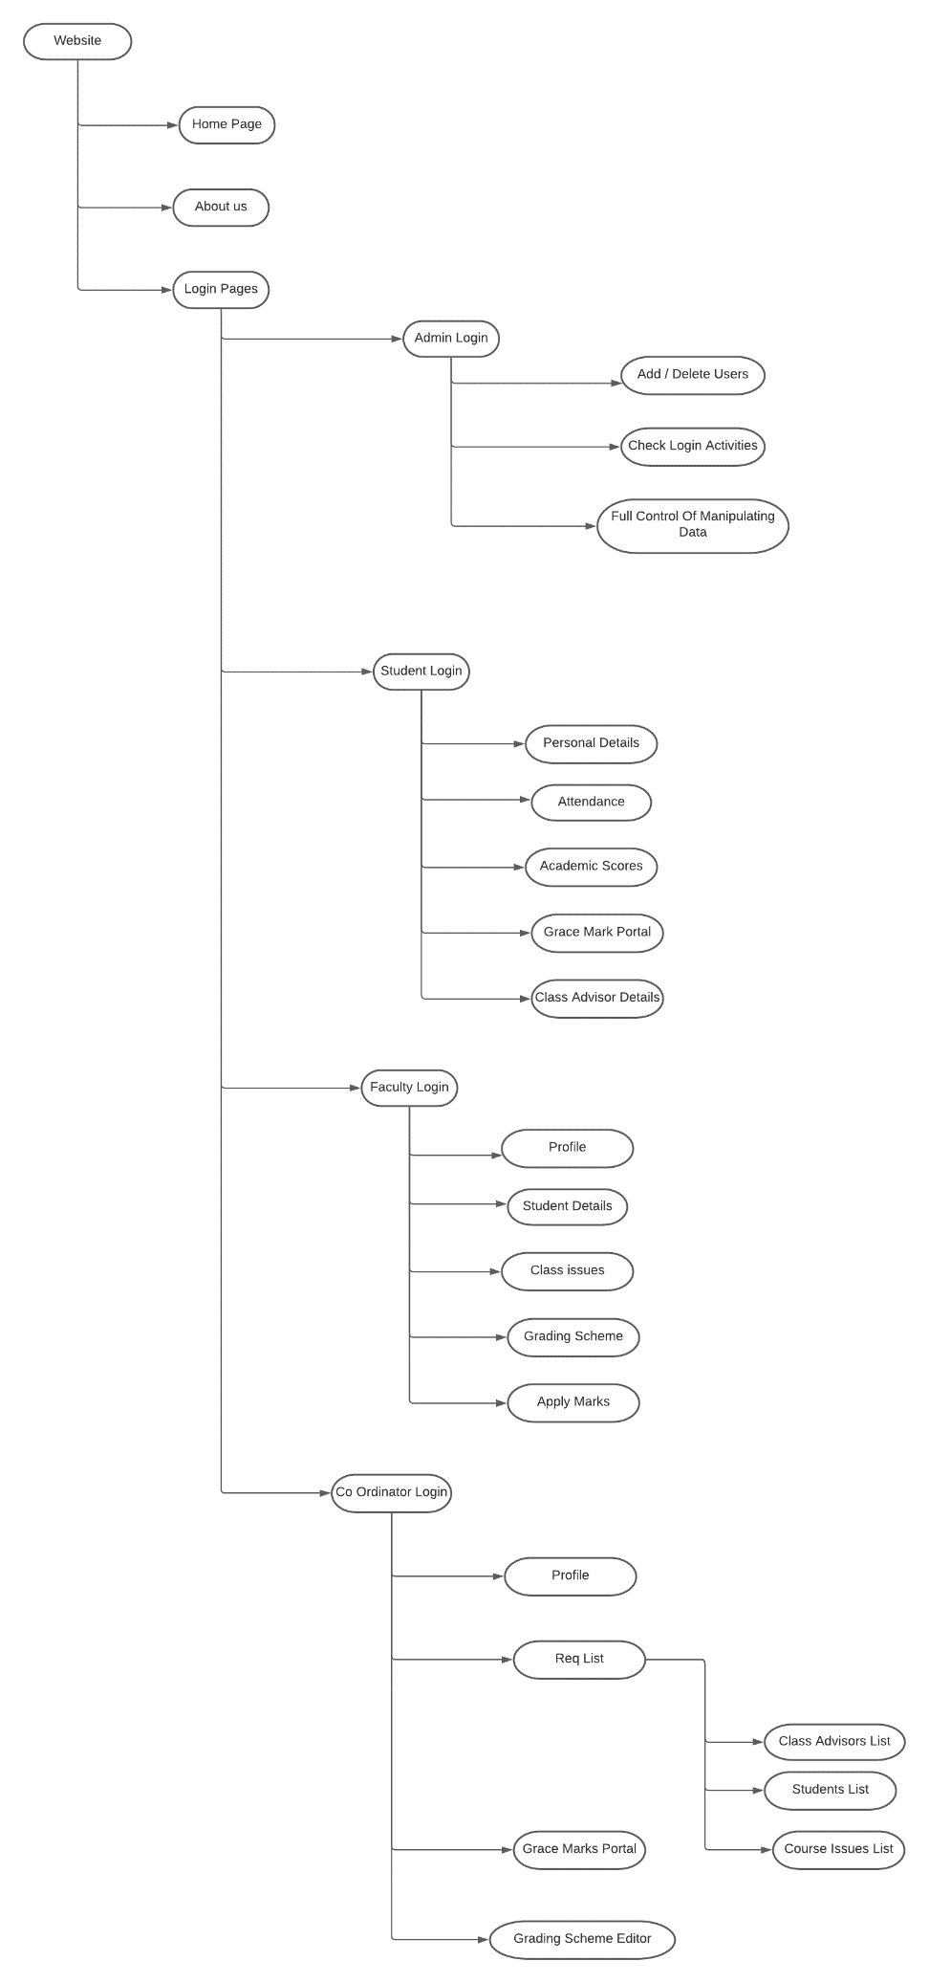**Design diagram:**

**Implementation:**

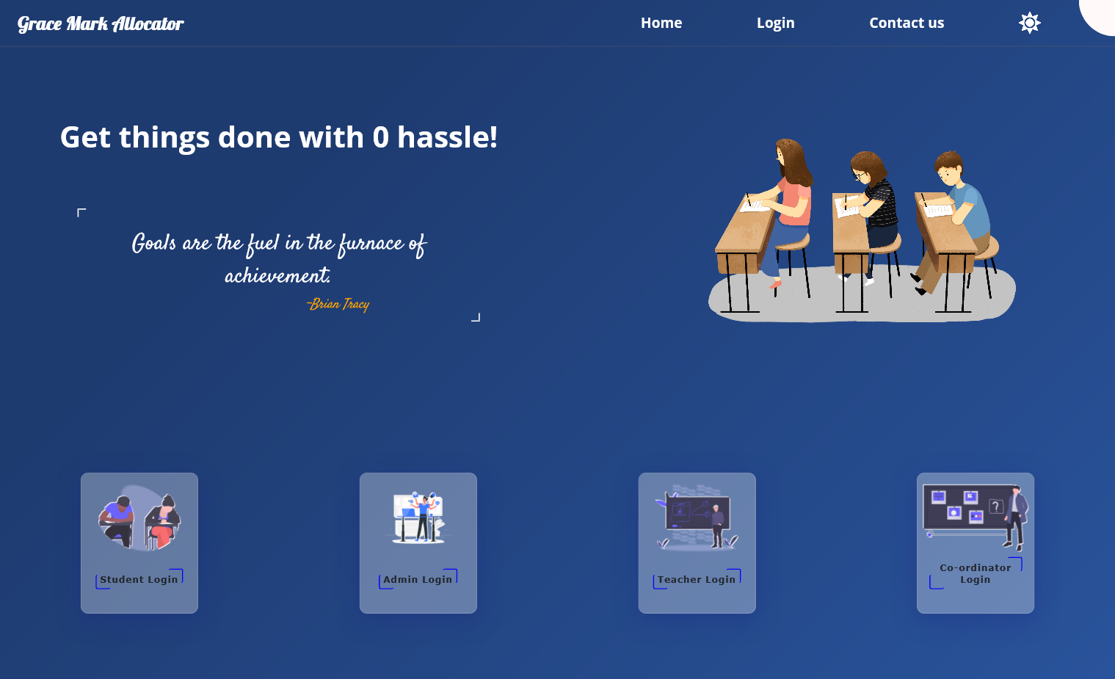

**Description:**

This page is the landing page of our website where users can choose their respective login page.

**Code snippet:**

<!DOCTYPE html>

<html lang="en">

  <head>

    <meta charset="UTF-8" />

    <meta http-equiv="X-UA-Compatible" content="IE=edge" />

    <meta name="viewport" content="width=device-width, initial-scale=1.0" />

    <title>Document</title>

    <link rel="stylesheet" href="http://localhost:5000/css/home.css" />

  </head>

  <form method="GET", action="http://localhost:8000/">

  <body>

    <div class="header">

      <h2 class="head">Grace Mark Allocator</h2>

      <div class="login">

        <a href="">Home</a>

        <a href="#box">Login</a>

        <a class="contact" href="">Contact us</a>

        <img class="mode" src="http://localhost:5000/img/sun.png" id="icon" />

        <!-- <a class="mode" href="">Mode</a> -->

      </div>

    </div>

    <div class="container">

      <div class="mini-cont">

        <h1>Get things done with 0 hassle!</h1>

        <div class="quotes">

          <blockquote class="quote"></blockquote>

          <div class="author"></div>

        </div>

      </div>

      <div class="image">

        <img

          src="http://localhost:5000/img/—Pngtree—students at the college entrance_4519946.png"

          alt=""

        />

      </div>

    </div>

    <section id="section1">

      <div class="box" id="box">

        <img src="http://localhost:5000/img/undraw_exams_g4ow.svg" alt="" />

        <div class="btn-box">

          <button formaction="/Student">Student Login</button>

        </div>

      </div>

      <div class="box admin">

        <img src="http://localhost:5000/img/Admin-rafiki.svg" alt="" />

        <div class="btn-box">

          <button formaction="/Admin">Admin Login</button>

        </div>

      </div>

      <div class="box">

        <img src="http://localhost:5000/img/undraw_teaching_f1cm.svg" alt="" />

        <div class="btn-box">

          <button formaction="/Faculty">Teacher Login</button>

        </div>

      </div>

      <div class="box">

        <img src="http://localhost:5000/img/undraw_quiz_nlyh.svg" alt="" />

        <div class="btn-box">

          <button formaction="/Coordinator">Co-ordinator Login</button>

        </div>

      </div>

    </section>

    <nav class="nav-bar">

      <ul class="nav-links">

        <div class="ourTeam">

          <h3><a href="http://localhost:5000/contact.html"> Our Team </a></h3>

          <img src="http://localhost:5000/img/teams.png" alt="" />

        </div>

        <div class="git">

          <h3>

            <a

              href="https://github.com/awezrebel/Grace-marks-Calculator"

              target="blank"

              >Github</a

            >

          </h3>

          <img src="http://localhost:5000/img/git.png" alt="" />

        </div>

      </ul>

      <div class="contacts">

        <h2>Stay in touch!</h2>

      </div>

    </nav>

    <script src="http://localhost:5000/js/home.js"></script>

  </body>

</html>

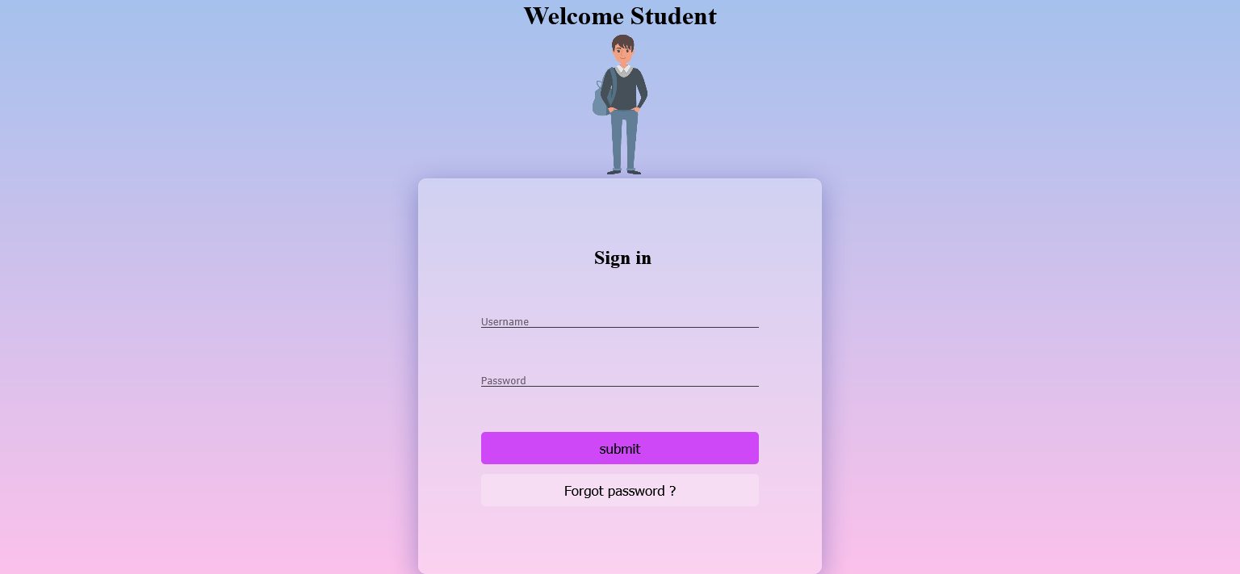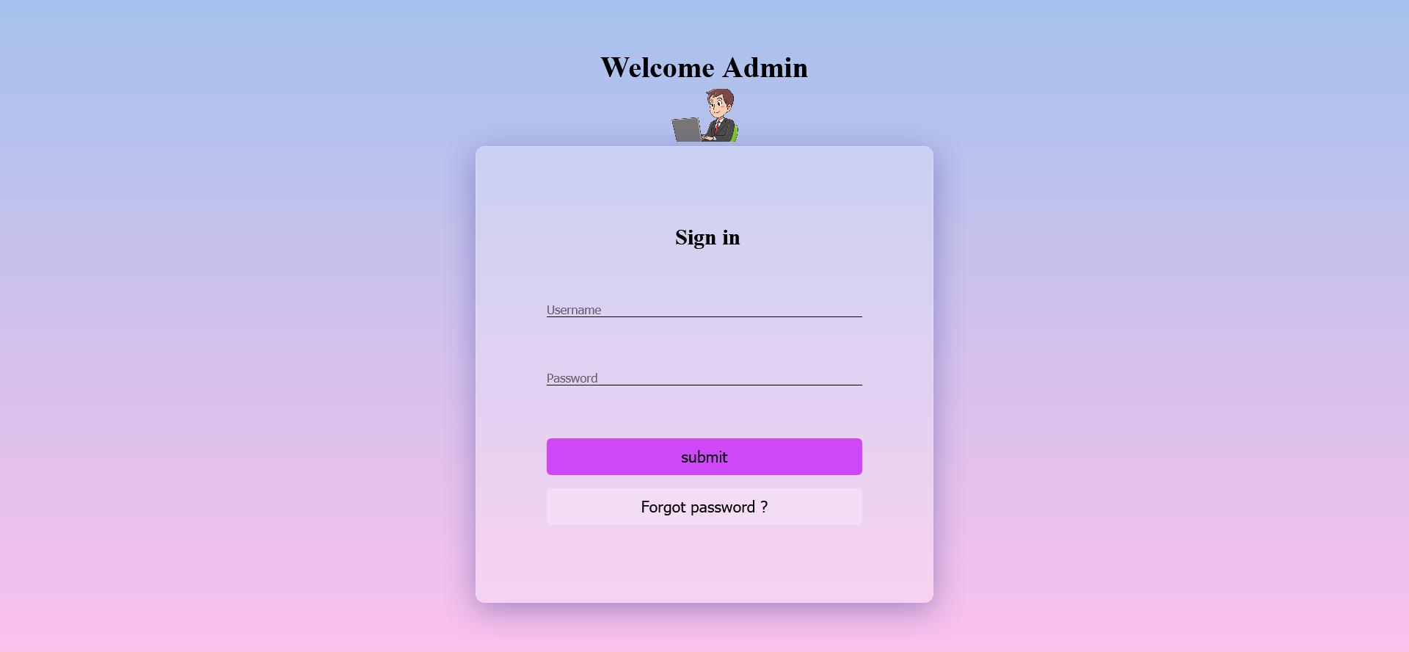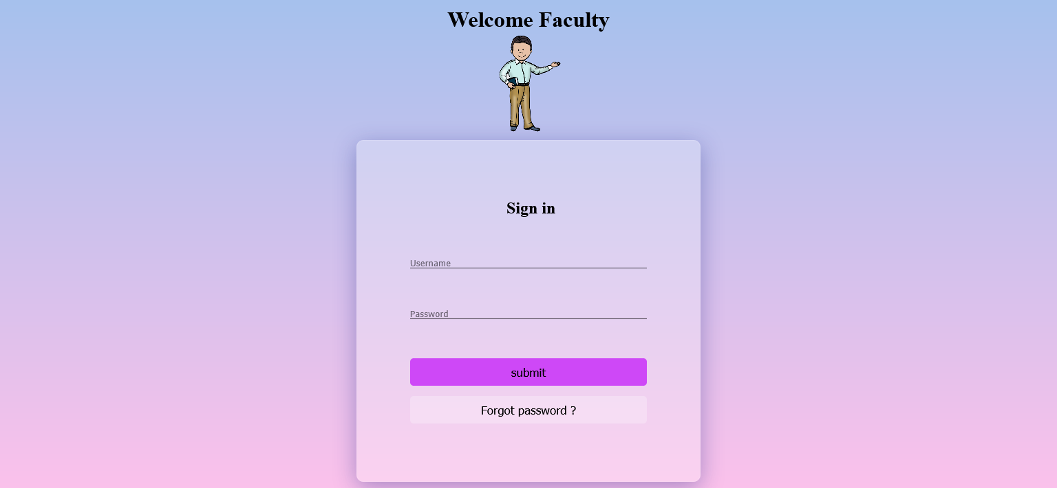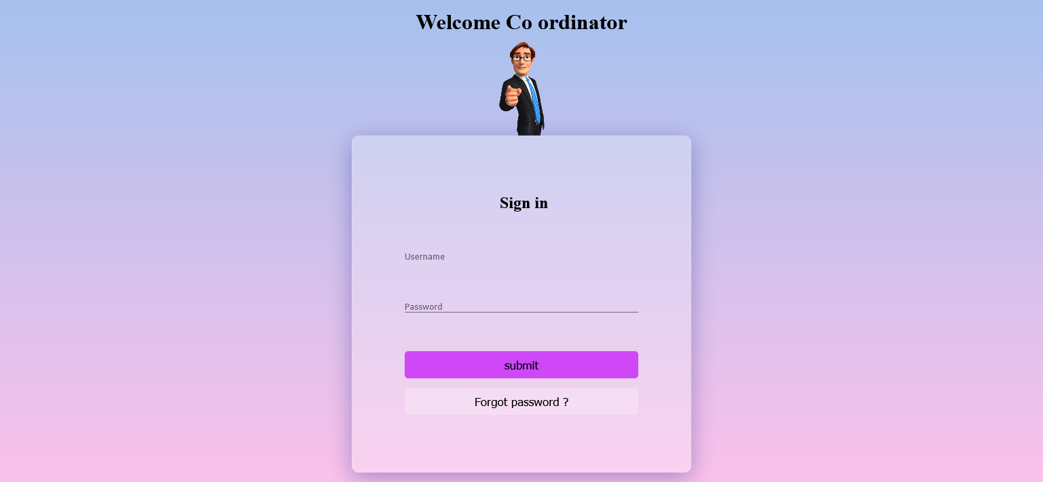

**Description:**

These are the different login pages done using single ejs file

**Code snippet:**

<!DOCTYPE html>

<html lang="en">

<head>

    <meta charset="UTF-8" />

    <meta http-equiv="X-UA-Compatible" content="IE=edge" />

    <meta name="viewport" content="width=device-width, initial-scale=1.0" />

    <title>Document</title>

    <link rel="stylesheet"  type="text/css" href="http://localhost:5000/css/style.css" />

</head>

<style>

       a{

        color: black;

    font-size: larger;

    text-align: center;

    margin-top: 5%;

    text-decoration: none;

    }

</style>

    <form method="GET", action="http://localhost:8000/">

<body>

    <div class="main-container">

        <div class="slider-container">

            <div class="left-slide">

                <div class="sign-in">

                    <h1>

                        <%= "Welcome "  +   welcome.Name %>

                    </h1>

        <img src ="  <%=welcome.image %>   "  width="100px">

                    <div class="sign-in-box">

                        <div class="head">

                            <h2>Sign in</h2>

                        </div>

                        <div class="username-field">

                            <i></i>

          <input type="text"  placeholder="Username"  name="username" />

                        </div>

                        <div class="password-field">

                            <i></i>

           <input type="password" placeholder="Password" name="password"/>

                        </div>

                        <button   formaction="/homelogin">submit</button>

                        <br><br>

<button  style="backgroundcolor:inherit;"  formaction="forgot">Forgot password ?</button>

                    </div>

                    </div>

            </div>

        </div>

    </div>

    <script src="http://localhost:5000/home.js"></script>

</body>

</html>

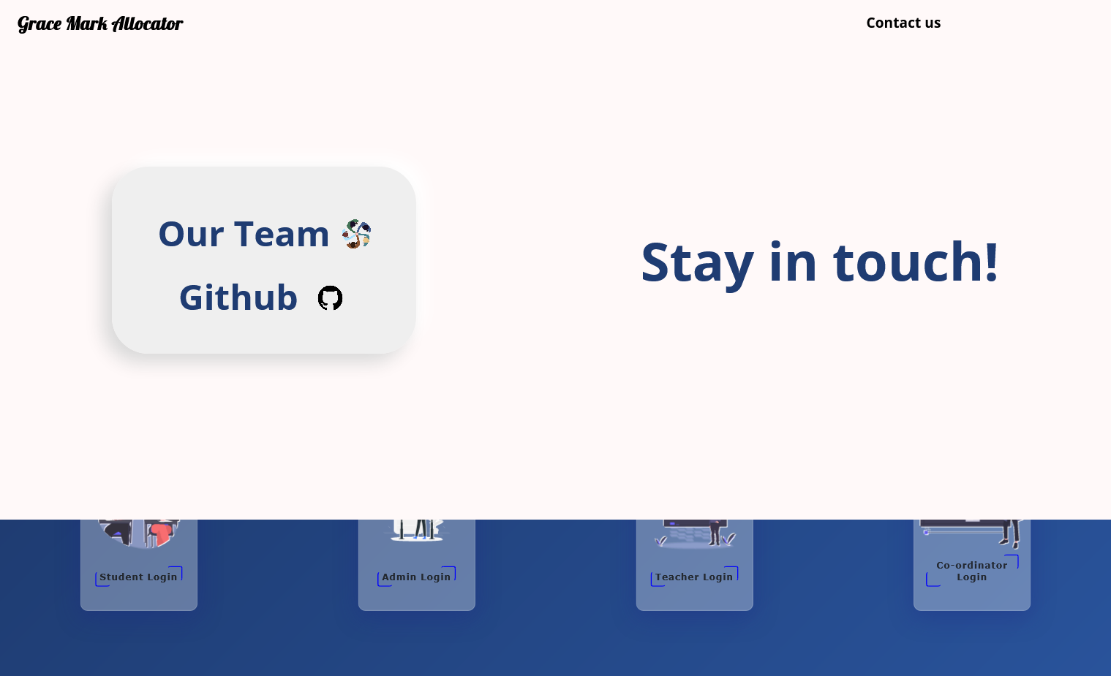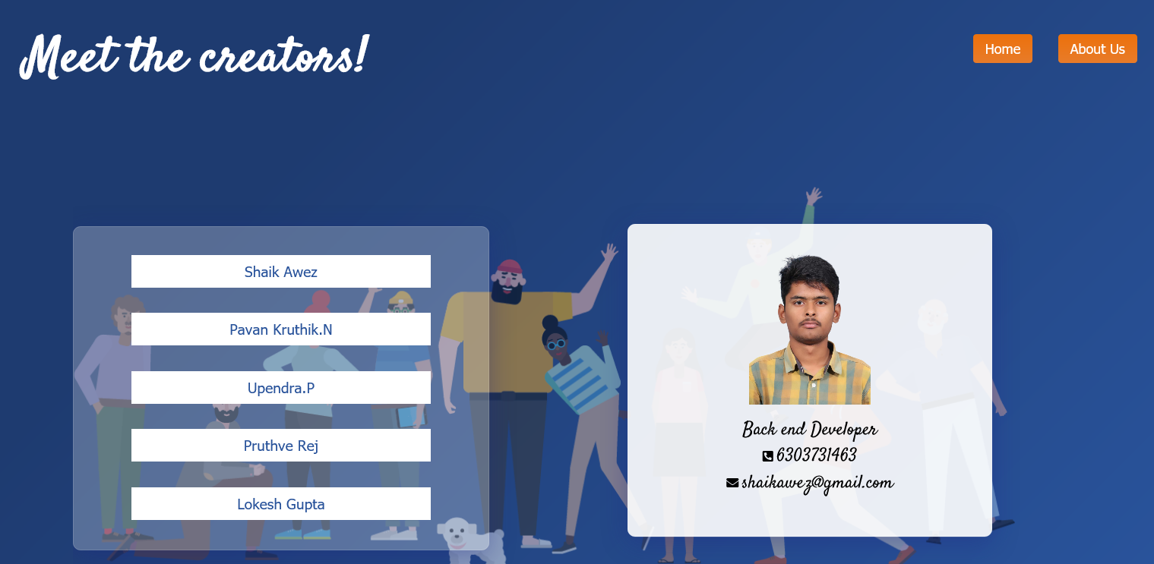

**Description:**

About us and git hub link From Home page

**Code snippet:**

<!DOCTYPE html>

<html lang="en">

<head>

    <meta charset="UTF-8" />

    <meta http-equiv="X-UA-Compatible" content="IE=edge" />

    <meta name="viewport" content="width=device-width, initial-scale=1.0" />

    <title>Contact Us</title>

    <link rel="stylesheet" href="http://localhost:5000/css/contact.css" />

    <link rel="stylesheet" href="https://cdnjs.cloudflare.com/ajax/libs/font-awesome/5.15.4/css/all.min.css" integrity="sha512-1ycn6IcaQQ40/MKBW2W4Rhis/DbILU74C1vSrLJxCq57o941Ym01SwNsOMqvEBFlcgUa6xLiPY/NS5R+E6ztJQ==" crossorigin="anonymous" referrerpolicy="no-referrer" />

</head>

<style>

.home {

position: absolute;

top: 0.8rem;

right: 10rem;

}

.home button {

background: #ed710c;

background-image: -webkit-linear-gradient(top, #ed710c, #e87c2a);

background-image: linear-gradient(to bottom, #ed710c, #e87c2a);

border-radius: 4px;

text-align: center;

color: #ffffff;

font-size: 18px;

padding: 0.5rem;

padding-right: 1rem;

padding-left: 1rem;

text-decoration: none;

border: none;

cursor: pointer;

transition: all 0.5s ease-in-out;

}

.home button:hover {

background: #3cb0fd;

text-decoration: none;

}

</style>

<body>

    <div class="header">

        <div class="messsage">

            <h1>Meet the creators!</h1>

        </div>

        <div class="about-us">

            <button>About Us</button>

        </div>

        <div class="home">

            <form method="get" action="http://localhost:8000/home">

                <button type="submit">Home</button>

            </form>

        </div>

    </div>

    <div class="img-container">

        <div class="image">

            <img src="http://localhost:5000/img/Teammates.png" />

        </div>

        <div class="creator-btns">

            <div class="click-btns">

                <a href="#item1">

                    <button>Shaik Awez</button>

                </a>

            </div>

            <div class="click-btns">

                <a href="#item2">

                    <button>Pavan Kruthik.N</button>

                </a>

            </div>

            <div class="click-btns">

                <a href="#item3">

                    <button>Upendra.P</button>

                </a>

            </div>

            <div class="click-btns">

                <a href="#item4">

                    <button>Pruthve Rej</button>

                </a>

            </div>

            <div class="click-btns">

                <a href="#item5">

                    <button>Lokesh Gupta</button>

                </a>

            </div>

        </div>

        <div class="creator-container">

            <div class="item" id="item1">

                <img src="http://localhost:5000/img/awez.png" alt="">

                <span>Back end Developer</span>

                <div class="details">

                    <i class="fas fa-phone-square-alt"></i>

                    <span>6303731463</span>

                    <div class="mail">

                        <i class="fas fa-envelope"></i>

                        <span>shaikawez@gmail.com</span>

                    </div>

                </div>

            </div>

            <div class="item" id="item2">

                <img src="http://localhost:5000/img/pavan.png" alt="">

                <span>Front end Developer</span>

                <div class="details">

                    <i class="fas fa-phone-square-alt"></i>

                    <span>8341900899</span>

                    <div class="mail">

                        <i class="fas fa-envelope"></i>

                        <span>kruthik24@gmail.com</span>

                    </div>

                </div>

            </div>

            <div class="item" id="item3">

                <img src="http://localhost:5000/img/upendra.png" alt="">

                <span>Front end Developer</span>

                <div class="details">

                    <i class="fas fa-phone-square-alt"></i>

                    <span>9182410276</span>

                    <div class="mail">

                        <i class="fas fa-envelope"></i>

                        <span>p_upendra@gmail.com</span>

                    </div>

                </div>

            </div>

            <div class="item" id="item4">

                <img src="http://localhost:5000/img/pruthve.png" alt="">

                <span>Tester</span>

                <div class="details">

                    <i class="fas fa-phone-square-alt"></i>

                    <span>9381044045</span>

                    <div class="mail">

                        <i class="fas fa-envelope"></i>

                        <span>p_pruthve@gmail.com</span>

                    </div>

                </div>

            </div>

            <div class="item" id="item5">

                <img src="http://localhost:5000/img/lokesh.png" alt="">

                <span>Tester</span>

                <div class="details">

                    <i class="fas fa-phone-square-alt"></i>

                    <span>8142838171</span>

                    <div class="mail">

                        <i class="fas fa-envelope"></i>

                        <span>g_lokesh@gmail.com</span>

                    </div>

                </div>

            </div>

        </div>

    </div>

    <script src="http://localhost:5000/js/contact.js"></script>

</body>

</html>

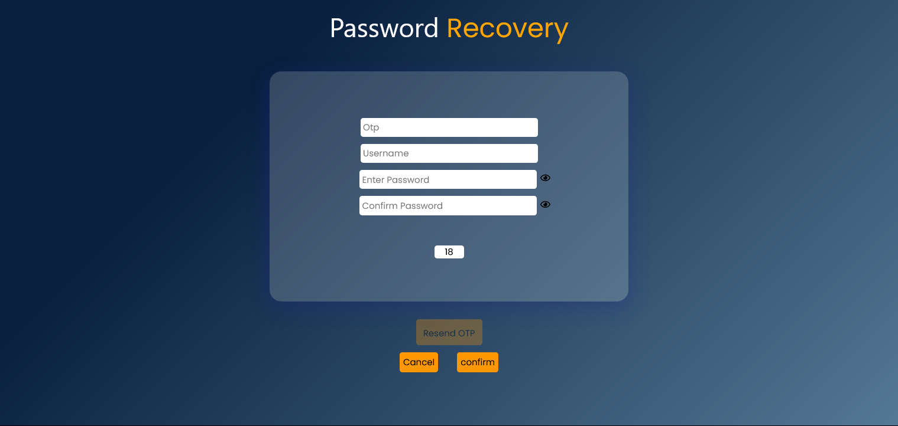

**Description:**

Forgot password page , with the help of otp generated to mobile

can reset password , done validations for each input feild

**Code snippet:**

<!DOCTYPE html>

<html lang="en">

<head>

  <title>OTP</title>

  <meta name="viewport" content="width=device-width, initial-scale=1">

  <link rel="stylesheet" href="https://www.w3schools.com/w3css/4/w3.css">

  <link rel="stylesheet" href="https://cdnjs.cloudflare.com/ajax/libs/font-awesome/5.13.0/css/all.min.css">

<body>

  <header>

    <h2>Password <span>Recovery</span></h2>

  </header>

  <form method="GET", action="http://localhost:8000/">

      <div class="inputs">

<input type="text" placeholder="Otp" name="otp">

<input type="text" placeholder="Username" name="uname1">

<div class="password">

<input type="password" placeholder="Enter Password"   name="pwd" id="pwd">

<em class="far fa-eye" onclick="password()"></em>

        </div>

        <div class="confirm-password">

<input type="password" placeholder="Confirm Password"   name="cpwd" id="cpwd">

          <em class="far fa-eye" onclick="confirmpassword()"></em>

        </div>

        <div id="countdown"></div>

      </div>

    <script>

      function password() {

        var x = document.getElementById("pwd");

        if (x.type === "password") {

          x.type = "text";

        } else {

          x.type = "password";

        }

      }

      function confirmpassword() {

        var x = document.getElementById("cpwd");

        if (x.type === "password") {

          x.type = "text";

        } else {

          x.type = "password";

        }

      }

    </script>

    <button class="w3-btn w3-orange" id="mybutton" formaction="/otp">Resend OTP</button> <br><br>

    <p>

<button  formaction="/home" , class="w3-btn w3-orange">Cancel</button>   &nbsp; &nbsp;

<button type="submit" , class="w3-btn w3-orange">confirm</button> <br><br>

    <p></p>

    <script>

      const htmlBtn = document.getElementById("mybutton");

      htmlBtn.disabled = true;

    </script>

    <script>

      alert("otp sent succesfully")

      var timeleft = 20;

      var downloadTimer = setInterval(function () {

        if (timeleft <= 0) {

          clearInterval(downloadTimer);

          document.getElementById("countdown").innerHTML = " ", htmlBtn.disabled = false;

        } else {

          document.getElementById("countdown").innerHTML = timeleft;

        }

        timeleft -= 1;

      }, 1000);

    </script>

  </form>

</body>

</html>

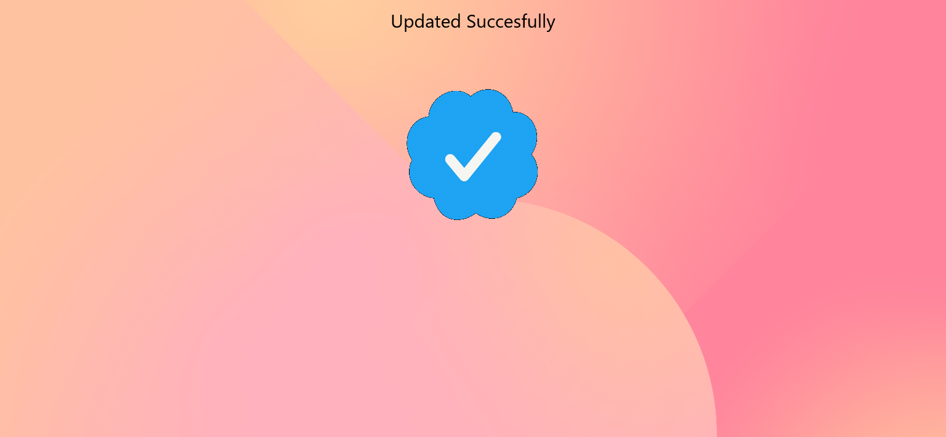

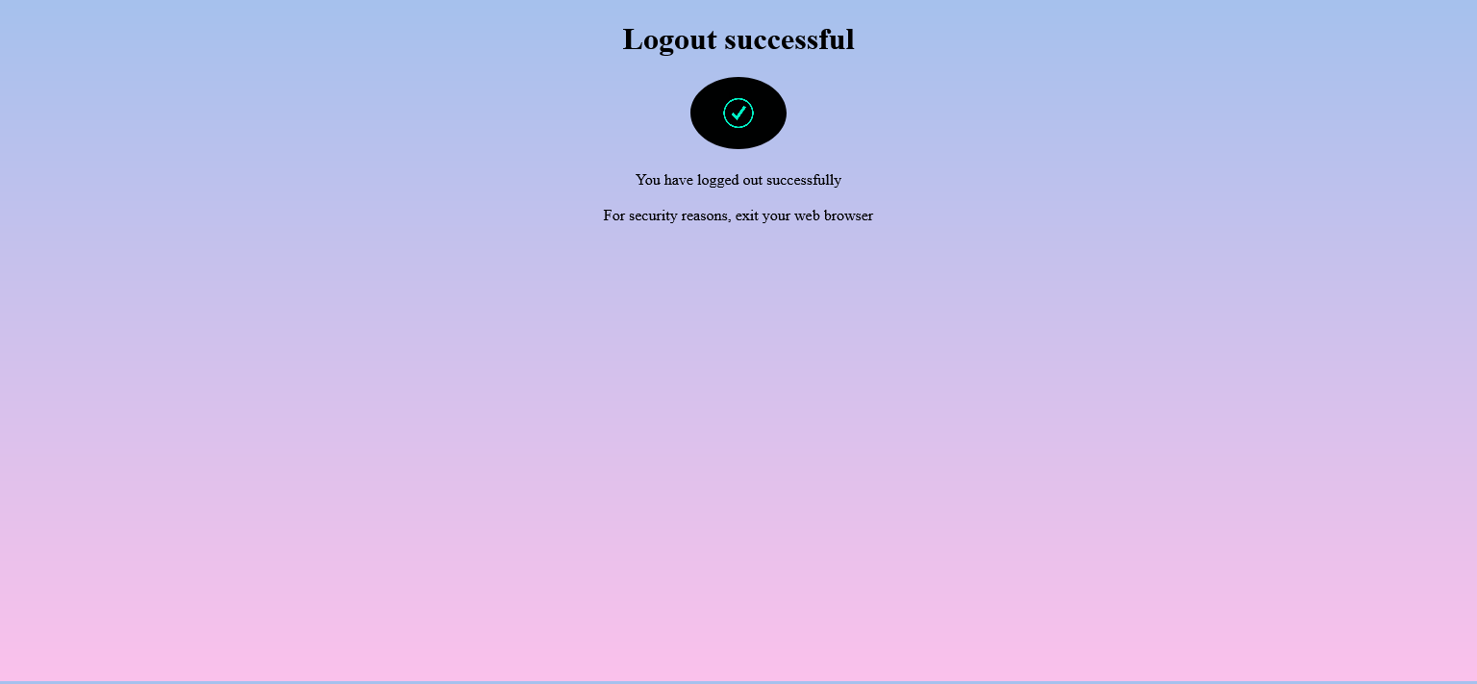

**Description :**

Basic logout page (Backward prevention script added), updation Acknowledge page after password reset

**Code snippet:**

<!DOCTYPE html>

<html lang="en">

<head>

<meta charset="UTF-8">

<meta name="viewport" content="width=device-width, initial-scale=1.0">

<style>

body{

    background-image: linear-gradient(to top, #fbc2eb 0%, #a6c1ee 100%);

    height: 95.5vh;

    justify-content: center;

    align-items: center;

     text-align: center;

}

img {

  border-radius: 50%;

}

</style>

<title>Logout</title>

<form method="GET", action="http://localhost:8000/">

</head>

<body>

    <script type="text/javascript">

        window.history.forward();

        function noBack()

        {

            window.onbeforeunload = function() { return "Your work will be lost."; };

        }

    </script>

<body onLoad="noBack();" onpageshow="if (event.persisted) noBack();" onUnload="">

<h1>Logout successful </h1>

<img src="https://i.pinimg.com/originals/70/a5/52/70a552e8e955049c8587b2d7606cd6a6.gif" width="100" alt="image not available"></img></br><br>

<p1> You have logged out successfully </p1><br>

 <br>

<p1> For security reasons, exit your web browser </p1> <br> </br>

<script type = "text/javascript" >

function preventBack() { window.history.forward(); }

setTimeout("preventBack()", 0);

window.onunload = function () { null };

</script>

</body>

</html>

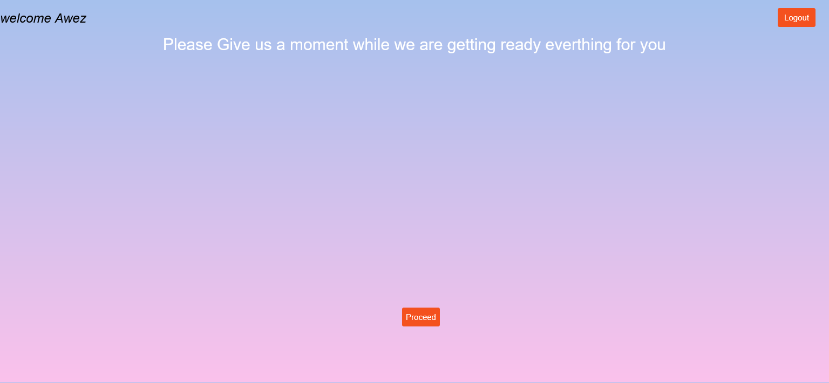

**Description:**

Welcome page with name , Fetched According to Login id with an Loading Animation

**Code snippet:**

<!DOCTYPE html>

<html lang="en">

<head>

    <meta charset="UTF-8">

    <meta http-equiv="X-UA-Compatible" content="IE=edge">

    <link rel="stylesheet" href="css/welcome.css">

<body>

<form method="GET", action="http://localhost:8000/">

        <% loginwelcome.forEach(function (login) { %>

           <h1>

             <%= "welcome  "  + login.name%>

            <% }) %>

         </h1>

       <h2> Please Give us a moment while  we are getting ready everthing for you</h2>

</tbody>

</table>

<button class="logout" formaction="/warning">Logout</button>

<button class="proceed" id="proceed" formaction="/data">Proceed</button>

</body>

</html>

**Evaluation sheet:**

|  |  |  |  |  |
| --- | --- | --- | --- | --- |
| Roll No | Technology | Max Marks | Marks Awarded | Total (30) |
| 18117 | HTML  CSS | 10  10 |  |  |
| 18136 | HTML  CSS | 10  10 |  |  |
| 18137 | HTML  CSS | 10  10 |  |  |
| 18138 | HTML  CSS | 10  10 |  |  |
| 18148 | HTML  CSS | 10  10 |  |  |
|  | Project Documentation | 10 |  |  |